OXID eSales
Documentation

Paymorrow Payments Module

User Manual

Copyright
Copyright © 2017 OXID eSales AG, Germany
Copying of this document or its contents, in particular, using texts or parts of text is subject to the explicit prior permission by OXID eSales AG.

The information provided in this document was prepared according to the current state of the art. OXID eSales, however, will assume no liability or warranty for the timeliness, correctness and completeness of the information provided. Since errors – despite all efforts – cannot be ruled out entirely, we always appreciate suggestions.

License
Licensing of the software product depends on the shop edition used.

The software for OXID eShop Community Edition is published under the GNU General Public License v3. You may distribute and/or modify this software according to the licensing terms published by the Free Software Foundation. Legal licensing terms regarding the distribution of software being subject to GNU GPL can be found under http://www.gnu.org/licenses/gpl.html.

The software for OXID eShop Professional Edition and Enterprise Edition is released under commercial license. OXID eSales AG has the sole rights to the software. Decompiling the source code, unauthorized copying as well as distribution to third parties is not permitted. Infringement will be reported to the authorities and prosecuted without exception.

Conventions
The following conventions are used:
proportional font with grey background
For user input, code and URLs
Grey italic
For filenames, file paths and other italic highlighting
Bold
For controls and navigation paths
Bold red
For warnings and important hints

Legal Notice
OXID eSales AG
Bertoldstrasse 48
79098 Freiburg
Germany
Fon: +49 (761) 36889 0
Fax: +49 (761) 36889 29
Executive board: Roland Fesenmayr (CEO), Dr. Oliver Ciupke
Supervisory board: Michael Schlenk (chairman)
Headquarters: Freiburg
Country court Freiburg i. Brg.
Commercial register number: HRB 701648

Table of contents

Copyright 2
License 2
Conventions 3
Legal Notice 3
Table of contents 4
1 Module Description 5
2 System requirements 5
3 Installation 5
3.1 Multi-Shop & -Language 6
3.2 Activate Module 6
3.3 Delete Temporary Files 6
4 Configuration 6
4.1 API-Configuration 6
4.2 Configure Payment Methods In Shop 7
4.3 Adjust Shipping Methods For Paymorrow In The Shop 7
5 Functional Description 8
5.1 Paymorrow Payments In The Checkout Process 8
5.2 Paymorrow Payments For Orders 11
5.3 OXID eShop Mobile Theme 11

Module Description
The Paymorrow Payments module handles the payment methods invoice and direct debit with guarantee of Paymorrow GmbH and is being developed and deployed by OXID eSales. In this way shop operators are protected against payment defaults, as the payment request is verified and confirmed in advance.

Module title: Paymorrow Payment
Version: 2.0
Category: OXID eFire Extension – Payment in the online shop
Manufacturer: OXID eSales AG
Internet: www.oxid-esales.com
E-mail: info@oxid-esales.com

For questions about Paymorrow products as well as support for module installation & setup, please contact Paymorrow.

- Product Consulting: beratung@paymorrow.de
- Technical Customer Service: technik@paymorrow.de
- URL: https://paymorrow.de

The Paymorrow Payments module was designed by OXID eSales in cooperation with Paymorrow.

System requirements
The system requirements given below apply to the Paymorrow Payments module.
- PHP >= 5.3
- cURL
- OpenSSL

Installation
In this chapter, the installation of the Paymorrow Payments module for the OXID eShop version 6.0.0 is described. Follow this guide step by step.

If the shop was set up as an OXID eShop Compilation, the matching version of Paymorrow Payment is already integrated. It simply has to be activated and configured via the admin panel. In case that the module has to be manually integrated into the shop please take a look at the README.md file of the module.

The technical customer service of Paymorrow also offers you a free module integration and set-up service. Please use the following contact information for communication with Paymorrow:
E-mail: technik@paymorrow.de & phone: +49 721 / 480 84 30

For contract partners, OXID eSales can carry out the installation of the module. The OXID eSales support can be reached via e-mail at support@oxid-esales.com.

Multi-Shop & -Language
If you have many sub-shops and more languages than English and German, please see comments in /modules/oxps/paymorrow/docs/install.sql to install all CMS snippets manually.

Activate Module
The module Paymorrow Payments should now be activated in the shop backend. Go to the shop backend to Extensions -> Modules and select the module. In the Overview tab, press the Activate button. By activating the module the database commands from /modules/oxps/paymorrow/docs/install.sql are executed automatically.

Delete Temporary Files
Clear the cache by removing /tmp folder content (all files except .htaccess).

Configuration
In order to enable payment via Paymorrow Payments for customers in the OXID eShop, the related module needs to be configured.

API-Configuration
Configuration of the Paymorrow Payments module in the admin panel:
Extensions -> Modules -> Paymorrow Payments -> Settings [tab] -> API Configuration

- Request your personal Webservice User and Initialization Code for the certificate registration via email to technik@paymorrow.de (live and/or test)
- Enter the Paymorrow Webservice User (live and/or test)
- Save the changes
- Then „Live/Test Register Certificates“ buttons will appear
- Use the Live or Test button to open a window where you enter the Initialization code and generate the certificate. The Initialization Code is supplied by Paymorrow and is a one-time code to generate a certificate

Configure Payment Methods In Shop
Mapping of the payment methods invoice and direct debit in the admin panel:
Shop Settings -> Payment Methods -> *any payment method available* -> Paymorrow [tab]

- Activate a payment method as Paymorrow and press Save
- Choose payment method type and configure Paymorrow tab
- If there are no errors in the form save it
- Make user group and country assignments (see Main and Country tab)
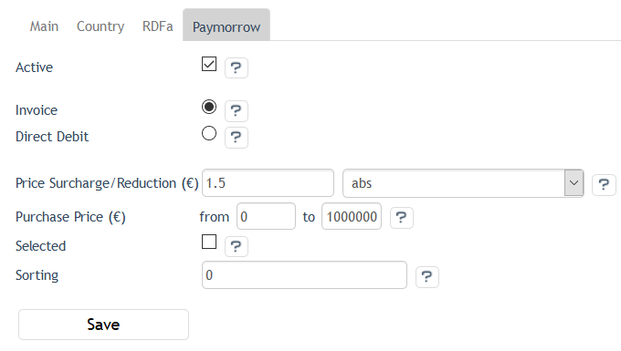
Figure 1: Admin panel, payment methods

Adjust Shipping Methods For Paymorrow In The Shop
Adjust all shipping methods, which are in use via Shop Settings -> Shipping Methods and assign them to the appropriate payment methods, countries, shipping cost rules and user groups.

Functional Description

Paymorrow Payments In The Checkout Process
Depending on the configuration of the Paymorrow Payments module, payment via invoice and direct debit is enabled during checkout step 3. At this time, the user is already logged in to the shop or shopping without registration. If the Paymorrow Payments module detects that any user data is missing, the user is required to enter the missing information.
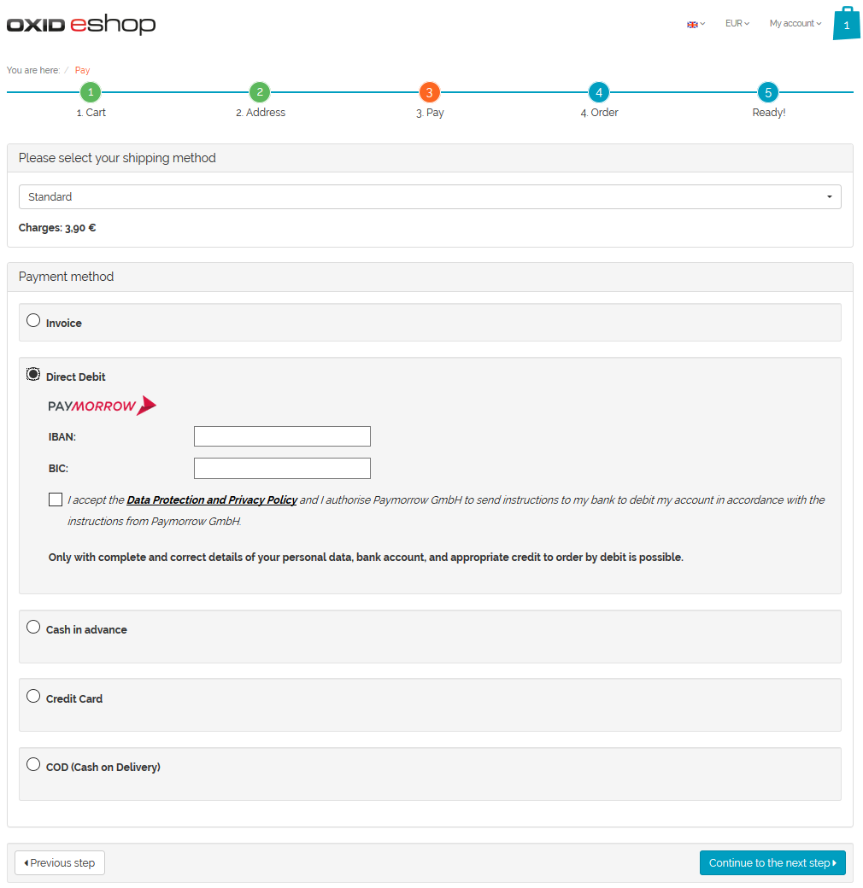
Figure 2: Checkout, order step 3, direct debit

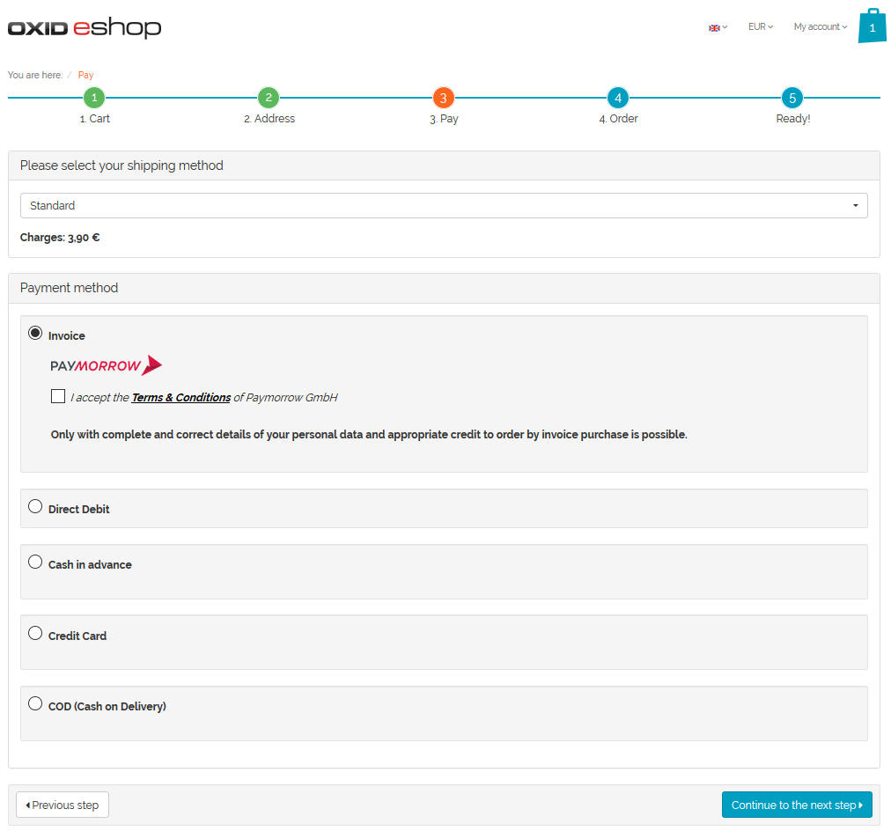
Figure 3: Checkout, order step 3, invoice

When the user continues to the next checkout step, the payment request is verified and confirmed in advance, e.g. by checking the credit rating of the customer.
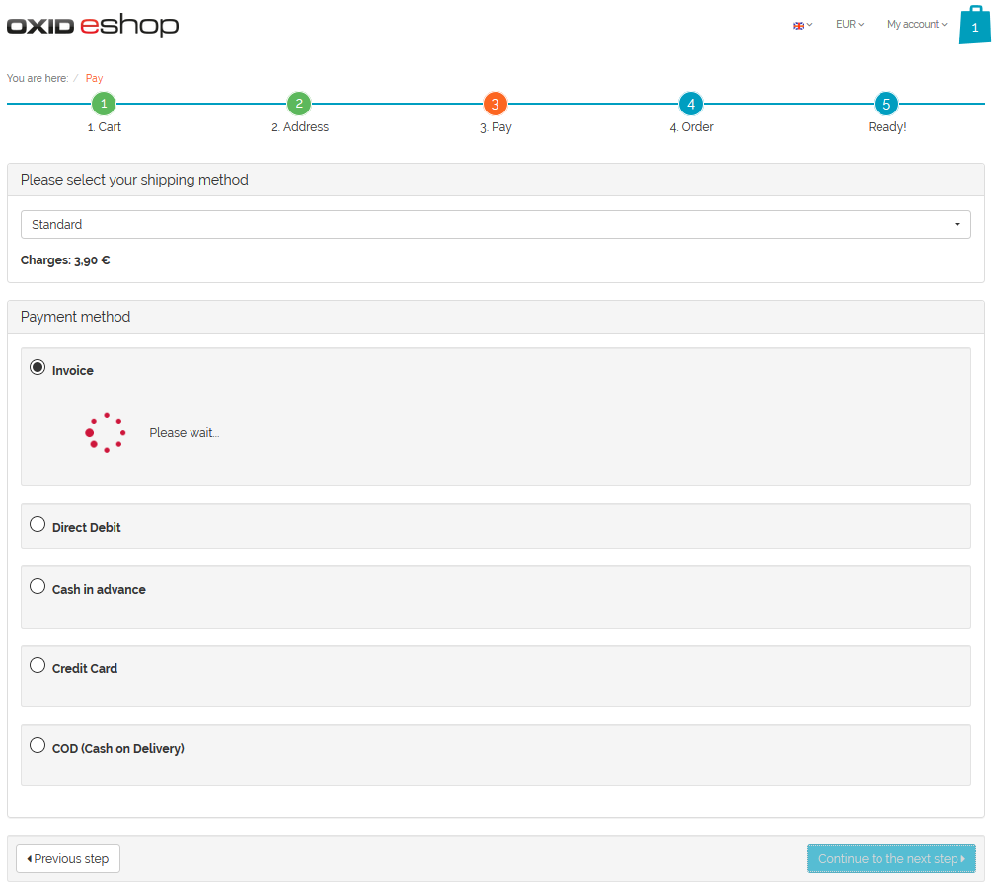
Figure 4: Checkout, order step 3, payment request validation

Paymorrow Payments For Orders
If products have been paid via a payment method mapped with Paymorrow Payments, a history of orders can be found in the admin panel. Therefore go to Administer Orders -> Orders. You can also find an overview of orders on the Paymorrow Merchant Portal (https://paymorrow.net/perthPortal/).
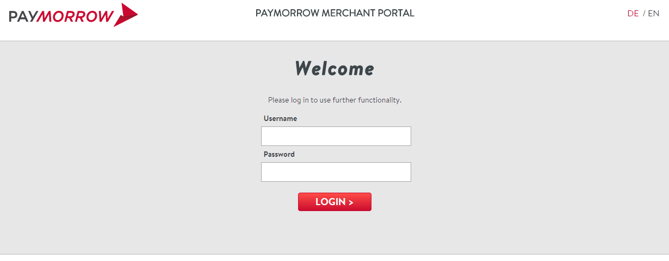
Contact Paymorrow GmbH in case you didn’t yet receive username and password.
Figure 5: Paymorrow Merchant Portal

OXID eShop Mobile Theme
Compatibility with the OXID eShop mobile theme is currently not provided.

